“ Financial Literacy and Portfolio Management in
India ”

A
Project Report
submitted in partial fulfillment of the
requirements for the award of the degree of

BACHELOR OF TECHNOLOGY
in
COMPUTER SCIENCE & ENGINEERING

by

Name | Roll No.
Anshuman Mohapatra | R2142230609

under the guidance of
Ms. Gaytri
(Assistant Professor)
Department of Systems

School Of Computer Science

School of Computer Science
University of Petroleum & Energy Studies
Bidholi, Via Prem Nagar, Dehradun, Uttarakhand
Dec - 2024

CANDIDATE’S DECLARATION

I/We hereby certify that the project work entitled “Financial Literacy and Portfolio Management in India ” in partial fulfilment of the requirements for the award of the Degree of BACHELOR OF TECHNOLOGY in COMPUTER SCIENCE AND ENGINEERING with specialization in <SPECIALIZATION) and submitted to the Department of Systemics, School of Computer Science, University of Petroleum & Energy Studies, Dehradun, is an authentic record of my/ our work carried out during a period from October, 2024 to December, 2024 under the supervision of Ms. Gaytri, Assistant Professor, Department Of Systems, School Of Computer Science.

The matter presented in this project has not been submitted by me/ us for the award of any other degree of this or any other University.

Anshuman Mohapatra
Roll No.- R2142230609

This is to certify that the above statement made by the candidate is correct to the best of my knowledge.

Date: 27th November, 2024

ACKNOWLEDGEMENT

I wish to express my deep gratitude to my guide Ms. Gaytri, for all advice, encouragement and constant support she has given us throughout our project work. This work would not have been possible without his support and valuable suggestions.

I would be also grateful to Dean SoCS UPES for giving me the necessary facilities to carry out my project work successfully. I also thank to my Course Coordinator, Anish Vishwakarma for providing timely support and information during the completion of this project.

I would like to thank all my friends for their help and constructive criticism during my project work. Finally, I have no words to express my sincere gratitude to my parents who have shown us this world and for every support they have given us.

INTRODUCTION

Problem Statement:
Only 27% of India's population is financially literate, leaving a significant majority without the necessary skills to manage their financial lives effectively. This lack of financial literacy hampers their ability to make informed financial decisions, leading to issues such as poor investment choices, debt traps, and limited access to financial services. The vast amount of financial data available necessitates a system that can manage and analyze this data to improve financial literacy.

Analysis Statement:
The current state of financial literacy in India is critical, with only a small fraction of the population having a minimum level of financial awareness. This issue is exacerbated by the lack of comprehensive financial education within the Indian education system, leading to suboptimal financial decisions and economic inequalities. Financial illiteracy affects not only the marginalized but also the middle and upper-middle classes, impacting overall economic growth and stability. Existing research highlights the importance of integrating financial literacy programs into education and the positive impact of such initiatives on individuals and the economy.

Proposed System Description:
The Financial Literacy and Management Platform aims to bridge the financial knowledge gap through an integrated, modular system. Key modules include a User Interface Module for streamlined user interaction, an Education Module offering personalized, demographic-based financial resources, an Asset Tracking Module to monitor various financial assets, a Performance Analytics Module providing actionable insights, and a Database Module for secure data management. This platform will empower users with the knowledge to make informed financial choices, effectively manage their portfolios, and track asset performance, thereby promoting financial self-sufficiency.

Conclusion Statement:
The proposed Financial Literacy and Management Platform is designed to empower individuals by enhancing their financial literacy and capabilities, thereby contributing to improved financial well-being and economic growth. By providing a comprehensive and user-friendly system, the platform aims to bridge the financial literacy gap in India and foster a more financially informed and secure society.
TABLE OF CONTENTS

INDEX

- Introduction
- Literature Review
- System Design
- Technical Stack
- Modules
- System Components
- Database Design
- Implementation
- MYSQL Code
- Output Screens
- Limitations
- Conclusion
- References

INTRODUCTION

Financial literacy is a critical component in fostering economic growth, promoting individual financial well-being, and enhancing the decision-making capabilities of citizens [1]. Despite its importance, studies show that India faces a significant gap in financial literacy, particularly among young adults in urban areas and rural populations, where financial understanding remains limited [2], [3]. This lack of awareness often results in inefficient money management and a limited capacity for wealth generation.

Financial inclusion is another vital area closely related to literacy, as it facilitates the integration of underserved communities into the mainstream economy. Research emphasizes that financial literacy and inclusion are interconnected, with improved literacy levels enabling more individuals to access essential financial services [4].

The primary challenges in this field include the uneven distribution of financial knowledge across different socio-economic groups, such as working women who exhibit lower literacy levels than their male counterparts, and the youth population which often lacks exposure to financial education [5]. Additionally, the complexity of financial decision-making is compounded by insufficient tools and resources to assist individuals in effectively managing their finances [6]. Furthermore, a significant portion of the population remains outside the formal financial system, hindering efforts toward equitable economic growth [4]. Addressing these issues requires a comprehensive approach that combines education, practical financial tools, and inclusivity.

This paper is organized as follows: Section 2 provides an extensive literature review that highlights previous studies on financial literacy and financial inclusion. Section 3 presents a detailed analysis of the current landscape and identifies key gaps in resources and education. Section 4 proposes a solution that integrates financial literacy education with practical asset management tools, and Section 5 discusses the findings and potential impact of implementing such a system. Finally, Section 6 concludes by emphasizing the need for a unified approach to improve financial literacy and inclusion across India.

LITERATURE REVIEW

Financial Literacy in India

Research highlights that financial literacy levels in India remain low, with only a fraction of the population equipped with adequate financial skills to make informed decisions [1]. A review of the literature by Sciendo emphasizes the critical role of financial education in enabling individuals to understand complex financial products and manage personal finances effectively [1]. This challenge is particularly apparent among young working adults in urban areas, as discussed in a study by Agarwalla et al., which underscores the limited financial awareness among this demographic [2]. Financial literacy also remains inconsistent across regions; for example, Uttar Pradesh and other states in Central India show varying literacy levels, with limited access to formal financial training in rural areas [3].

Barriers to Financial Inclusion and Literacy

Financial inclusion, while closely tied to literacy, faces its own challenges. Financial literacy directly influences individuals’ ability to access banking and financial services, a key factor in promoting equitable growth. Ozili’s review highlights that a lack of financial literacy limits participation in essential banking services, particularly in underserved rural communities [4]. Additionally, Arora’s work on working women in India reveals gender disparities in financial literacy levels, illustrating the need for targeted educational initiatives that consider socio-economic and gender-specific needs [5]. Furthermore, Lusardi’s research shows that individuals with higher financial literacy are better equipped to manage risk, a crucial skill in financial decision-making [6].

Objectives and Inferences

Based on the literature, the objectives of this study are defined as follows:
- To increase access to financial literacy resources across socio-economic groups, with a focus on youth and underserved populations.
- To develop a comprehensive financial literacy program that includes educational tools and a portfolio management system to aid in asset tracking and performance analytics.
- To promote inclusive financial practices by ensuring that literacy initiatives are accessible to all, particularly women and rural populations.

This section provides a foundation for identifying and addressing the gaps in financial literacy and inclusion. The findings underscore the importance of a unified approach that combines financial education with practical tools for managing and analyzing personal finances. Section 3 will discuss the analysis methodology used to assess financial literacy needs in more depth, and Section 4 will present the proposed solution to improve accessibility and usability for all users.

Inferences from Literature Review

The literature highlights several key areas of need:

- Educational Accessibility: There is a strong need for accessible financial education, particularly in rural and semi-urban areas, where literacy rates are disproportionately low.

- Behavioral Change: Financial education programs must address not only knowledge but also behavioral and attitudinal aspects to foster a comprehensive understanding of personal finance.

- Regional Customization: Tailored programs should be developed that consider the distinct socio-economic factors affecting different regions in India.

Defined Objectives

Based on these insights, the objectives of this research are as follows:

- To create a comprehensive financial literacy platform that combines educational resources with practical tools for financial management.

- To develop tailored educational content that meets the needs of diverse demographic groups, specifically targeting low-income and rural populations.

- To promote behavioral change by integrating features that encourage financial planning and decision-making skills.

SYSTEM DESIGN

The Financial Literacy and Portfolio Management System is designed using a Client-Server Architecture to ensure modularity, scalability, and efficient management of user data and financial records. The system is composed of (Database). This system will be implemented with MySQL for the backend database.

User Interface Components:
- Login/Registration:
- User authentication through email and password.
- Registration with role-based access (individual user vs. financial advisor).
- Dashboard:
- Displays financial portfolio summary: assets, current value, performance, etc.
- Real-time data updates showing changes in asset values (stocks, bonds, real estate).
- Financial Literacy Content:
- Section for educational resources, articles, and guides on investing, savings, budgeting, etc.
- Categorized by type (Investments, Stock Market, Budgeting, etc.) with state-based localization.
- Portfolio Management:
- CRUD (Create, Read, Update, Delete) operations for managing user portfolios.
- Users can add new assets (stocks, mutual funds, real estate) and manage their portfolio.

2. Data Layer (Database):

- Implemented using MySQL:
  - The MySQL database is used to persist all critical data such as user details, portfolio information, assets, educational content, and transaction history.
SQL Schema:

  - User Table:

    - Stores user credentials, roles, and basic profile information (name, email, income, location, password).
  - Asset Table:

    - Stores information about different financial assets (stocks, real estate, bank accounts).
  - Educational_Content Table:
    - Stores educational resources related to financial literacy and portfolio management (category, description, title, state).
  - Portfolio Table:

    - Tracks user portfolios, linking them to assets. It also stores the creation date and associated user.
  - User_Content Table:

    - Manages the content consumed by users, linking users to specific educational content (with a password for content access).

Technical Stack

- Database: MySQL (for persistent data storage)
- APIs: Integration with third-party services for real-time stock data and financial news
(POSSIBILITY, HASN’T BEEN USED TILL NOW)

Modules

- User Interface Module
  - Function: Displays educational content, asset information, and portfolio summaries to the user.
  - Output: User input (e.g., asset details, goals), selection of educational resources.

- Education Module
  - Function: Provides tailored financial education resources based on user demographics (e.g., age, income level).
  - Input: User selection from the interface.
  - Output: Educational content (e.g., articles, videos, quizzes).

- Asset Tracking Module
  - Function: Allows users to input and monitor various assets, such as stocks, bonds, and mutual funds.
  - Input: Asset details from the user.
  - Output: Asset portfolio overview.

- Performance Analytics Module
  - Function: Analyzes the performance of the user's financial portfolio and provides insights.
  - Input: Data from the Asset Tracking Module.
  - Output: Performance reports, insights (e.g., asset growth, risk levels).

- Database Module
  - Function: Stores user data, educational content, asset details, and performance metrics.
  - Input: Data from User Interface, Asset Tracking, and Education modules.
  - Output: Retrieved data for real-time updates and analytics.

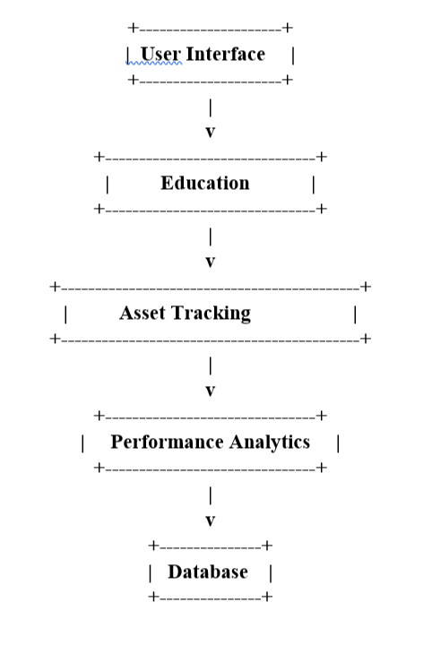System Components
- User Management:
  - User Registration: Allows users to sign up by providing personal details, including their name, age, email, income, location, and password.
  - Login and Logout: Provides secure access to the system by authenticating user credentials. Only authenticated users can access their portfolio and educational content.
- Portfolio Management:
  - Create Portfolio: Users can create financial portfolios by associating their accounts with different assets (stocks, real estate, and bank deposits).
  - Manage Portfolio: Allows users to track, update, and manage their portfolio by adding or removing assets, viewing performance, and updating portfolio details.
  - View Portfolio Details: Displays detailed information about the user’s portfolio, including asset types, values, and performance over time.
  - Portfolio Security: Users can set and manage portfolio passwords to ensure only authorized access to their portfolios.
- Asset Management:
  - View Asset Details: Displays information about financial assets, such as stocks, real estate properties, and bank accounts. Information includes type, value, and purchase price.
  - Add/Update Asset: Users can add new assets to their portfolio and update asset information as required.
- Educational Content Management:
  - Access Educational Content: Users can access educational resources related to finance, investing, budgeting, and other financial topics.
  - State-Based Content: Educational content is filtered and provided based on location, ensuring that region-specific content (e.g., tax rules) is presented.
- Database Layer:
  - Relational Database: A MySQL database stores all system data, including user details, assets, portfolios, and educational content.
    - User Data: Stores personal information of users (name, email, income, etc.).
    - Asset Data: Stores details about various assets like stocks, real estate, and bank accounts.
    - Portfolio Data: Links users to their portfolios, containing assets with associated creation dates.
    - Content Data: Stores educational content related to finance and investing, including categories and location-specific details.
  - Data Integrity: Ensures data consistency and relational integrity through foreign keys and cascades between users, assets, portfolios, and educational content.
- Security Features:
  - Role-Based Authentication: Ensures that only authenticated users can access and modify their portfolios and educational content.
  - Secure Password Storage: Passwords are stored securely using proper encryption methods to protect user credentials and sensitive data.
  - Database Connection Security: Secure connection to the database via JDBC to protect data in transit.
- Graphical User Interface (GUI):
  - Navigation: Provides an intuitive interface for users to easily navigate through their portfolio, educational content, and manage their financial assets.
  - Interactive Features: Allows users to interact with their portfolios, view asset data, and consume educational content in a simple and efficient manner.
Database Design

The database is designed to manage user data, financial assets, portfolios, educational content, and interactions between them. The structure includes the following tables:
- User Table: Stores personal details of users, including their ID, name, age, email, income, location, and password.
- Asset Table: Stores information about various financial assets, including stocks, real estate, and bank assets, as well as their current value and purchase details.
- Educational_Content Table: Stores financial educational resources such as articles, guides, and courses, organized by category and location.
- Portfolio Table: Links users to their portfolios, which contain financial assets. Each portfolio is associated with a user and contains asset information.
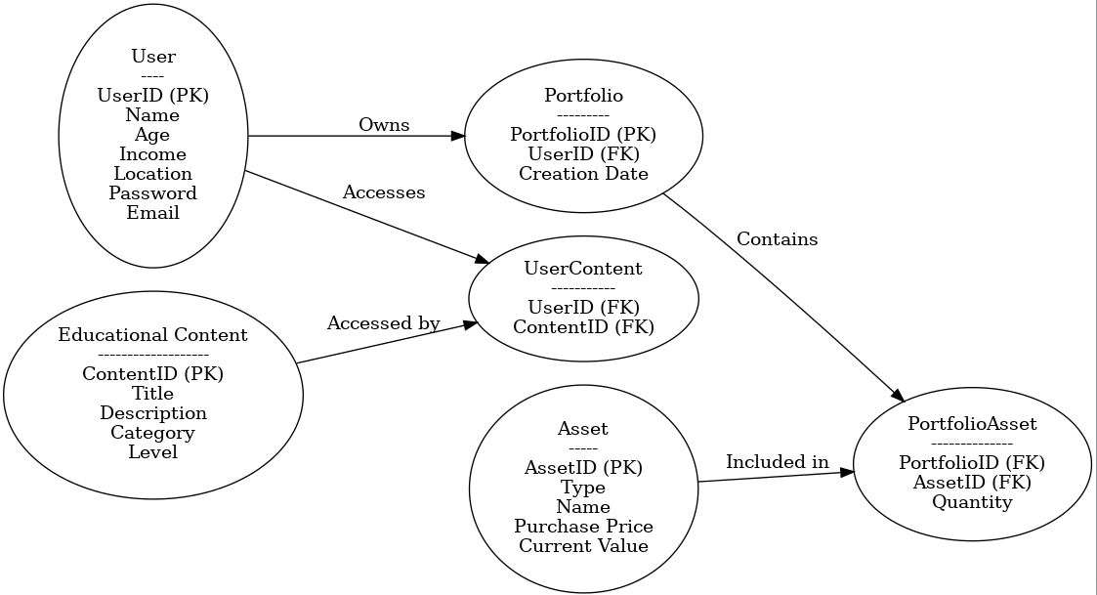
Implementation

Implementation of the Financial Literacy and Portfolio Management System
The Financial Literacy and Portfolio Management System was developed using MySQL as the relational database management system (RDBMS) for efficient data storage and management. MySQL's powerful relational database capabilities allow for robust handling of data, seamless interactions, and efficient business logic processing. In this section, we will discuss the technologies used, the overall database structure, and the core functionalities implemented within the system.

Technologies Used
MySQL:
MySQL serves as the relational database management system (RDBMS) for storing and managing all the data related to users, assets, educational content, portfolios, and more. MySQL’s strong relational database capabilities help ensure data integrity, consistency, and efficient querying, which are essential for the functioning of the system.
- Relational Database Structure: The database is structured into several interconnected tables that store crucial information. These include user profiles, details about various financial assets (stocks, real estate, etc.), educational content related to financial literacy, and portfolios that link users to their assets. This relational model ensures that all data is stored in an organized and easily accessible manner, enabling fast data retrieval and seamless interactions across different parts of the system.
- SQL Queries: MySQL supports the use of SQL (Structured Query Language), which is used extensively to perform operations like inserting new data records, updating asset values, deleting outdated content, and querying the database for specific financial information. SQL’s powerful querying features enable the system to run complex operations, such as calculating portfolio performance, generating detailed reports for users, and even performing trend analysis on asset values.

Core Functionalities Implemented
The system integrates MySQL to perform the following key functionalities:
- User Management: MySQL handles the storage and management of user information, such as names, ages, incomes, passwords, and contact details. This allows users to securely access and manage their profiles and portfolios.
- Portfolio Management: The system enables users to create and manage portfolios, where they can add or remove financial assets such as stocks, real estate, and bank accounts. MySQL processes portfolio operations and updates portfolio values based on asset prices or transactions.
- Asset Tracking and Value Calculation: The system tracks the value of different financial assets. MySQL stores asset details such as stock quantities, purchase prices, and real estate values. It also calculates the current value of assets based on market conditions or asset performance.
- Educational Content: The system provides users with access to financial literacy content, such as articles, guides, and tutorials. This content is stored in MySQL and categorized by type and region. MySQL enables users to access and track the materials they've viewed, ensuring they can return to previously accessed educational resources.
- Data Processing and Reporting: MySQL automates the process of calculating portfolio performance, such as determining the total value of a user's assets or generating reports on market trends. SQL queries are used to retrieve relevant data from MySQL, and the data is presented to users in a readable and actionable format.

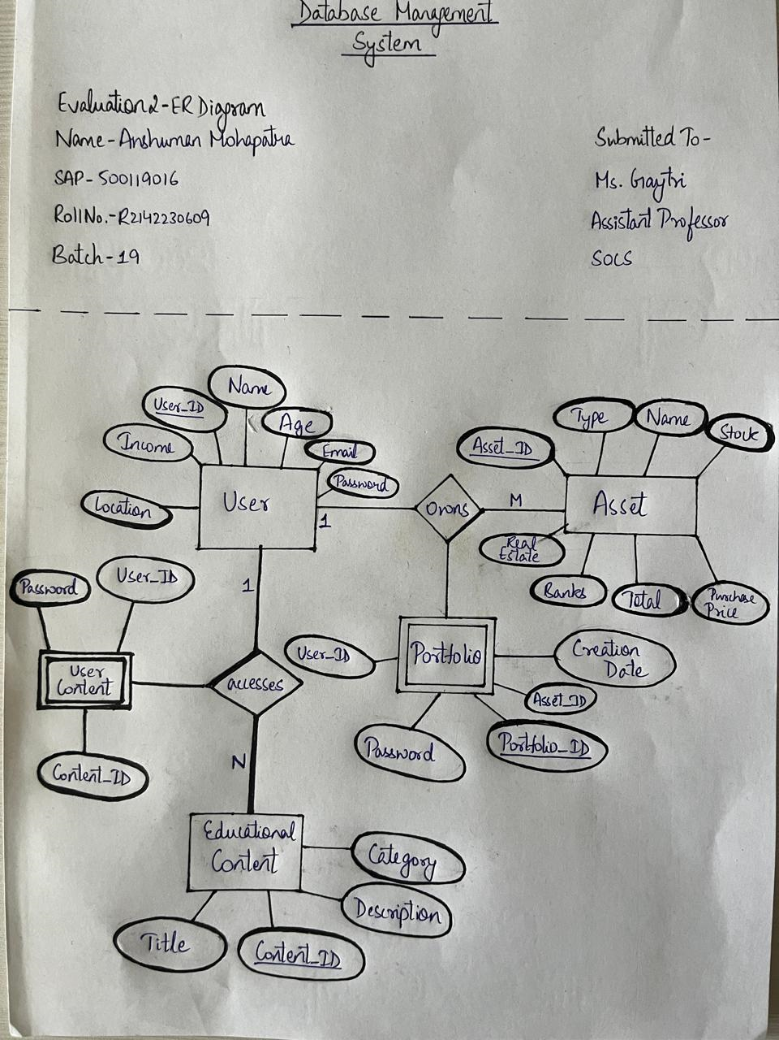

MYSQL

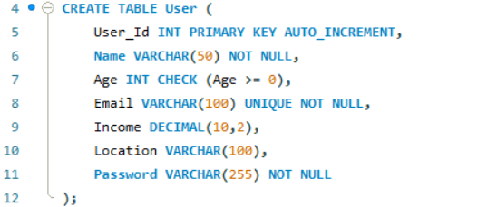
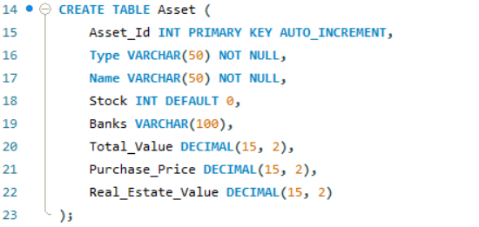
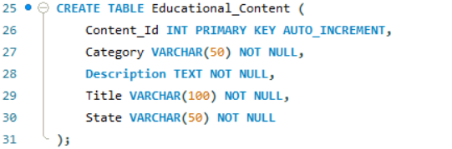
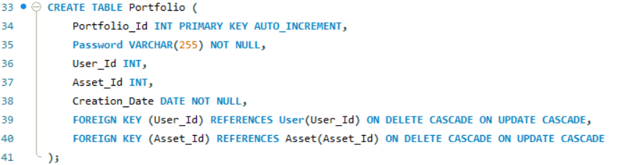
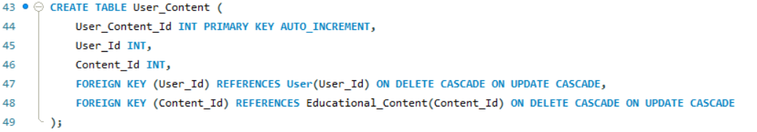
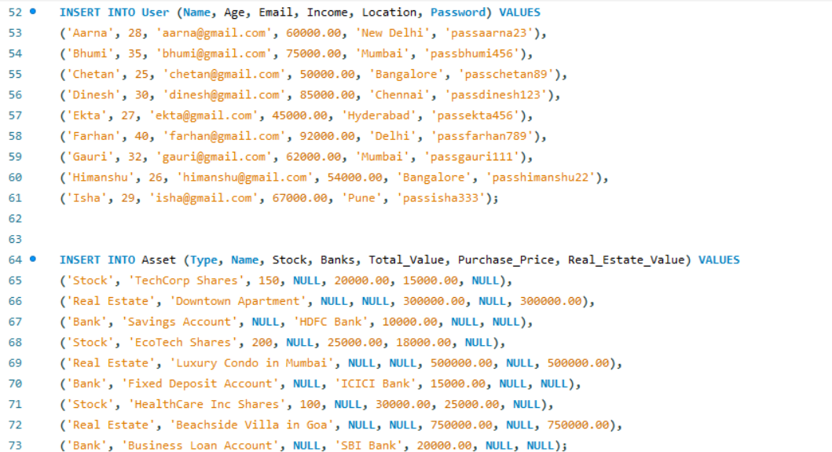
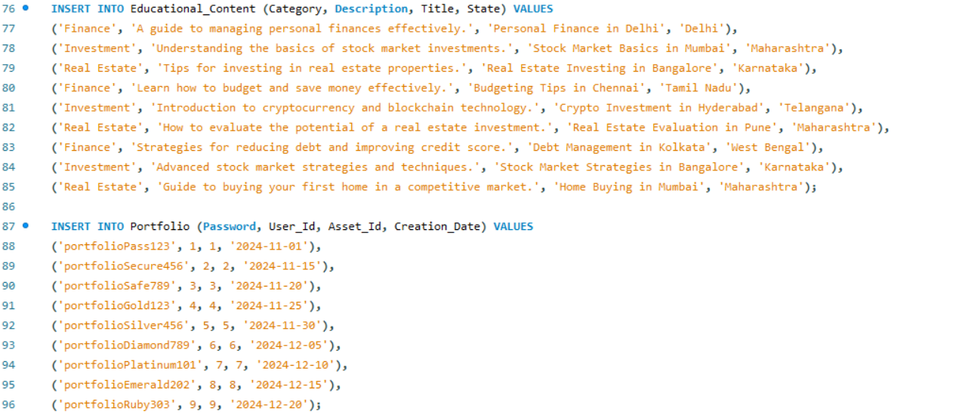
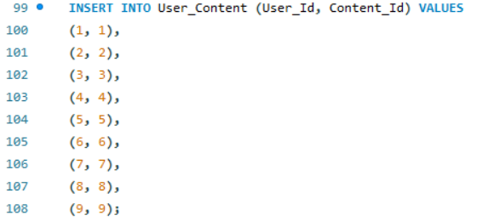

Output

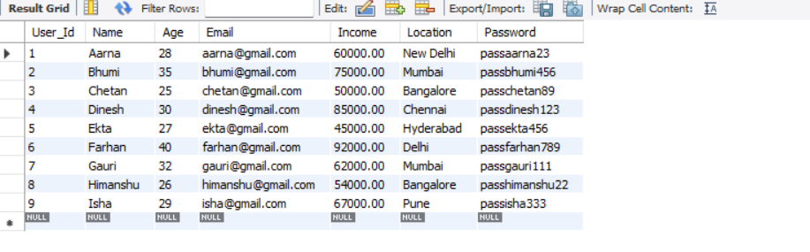

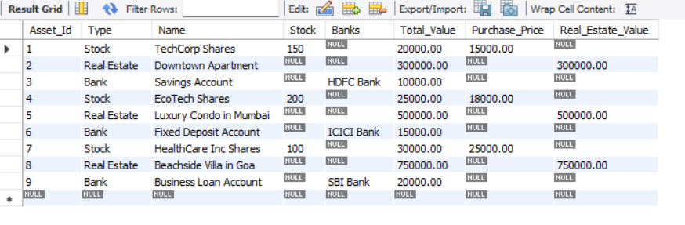
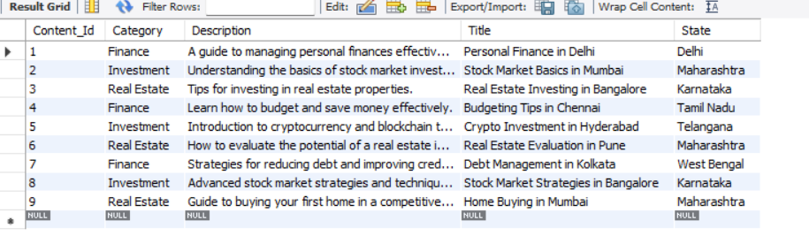
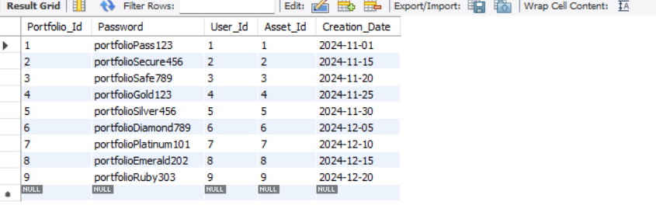
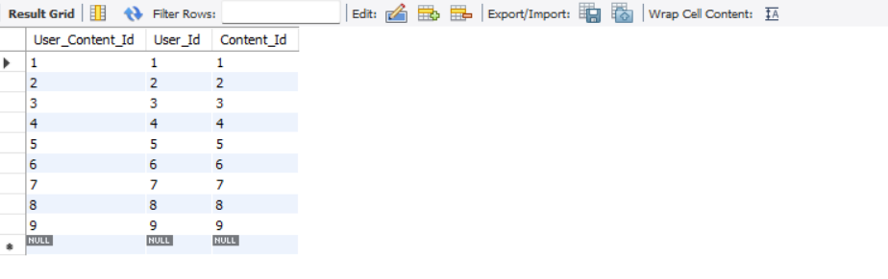

Limitations

Limitations of the Financial Literacy and Portfolio Management System in India
While the proposed Financial Literacy and Portfolio Management System aims to enhance financial literacy and help users manage their portfolios effectively, there are several limitations to its implementation and usage in India:

- Limited Digital Literacy: Despite the growing internet penetration in India, a significant portion of the population, especially in rural areas, lacks digital literacy. The system may be inaccessible to people who are not comfortable using digital platforms or do not have the necessary skills to navigate through an online system effectively.

- Internet Connectivity Issues: While urban areas in India are generally well-connected, many rural and remote regions still suffer from unreliable or slow internet connections. This can limit the accessibility and effectiveness of the system, especially if real-time data processing, updates, or educational resources require constant internet connectivity.

- Financial Knowledge Gaps: Although the Education Module provides tailored financial resources, the level of financial literacy in India is still quite low, particularly in rural and semi-urban areas. Users may find the educational content either too complex or irrelevant to their personal financial situation, reducing the system's impact on improving financial literacy

- Data Privacy and Security Concerns: The system collects sensitive user data, such as financial details, personal information, and portfolio data. There may be concerns regarding the security of this data, especially if there are no robust data protection policies or encryption mechanisms in place. With increasing cybersecurity threats, the system could be vulnerable to data breaches or hacking attempts.

- Lack of Personalization: While the system provides some degree of tailored content through the Education Module, true personalization may be difficult to achieve without deep integration with users' financial behavior and preferences. For instance, users may require advice based on real-time changes in their financial situation, which might be difficult to automate effectively without further development.

- Regulatory Challenges: India’s financial landscape is highly regulated, with specific rules and compliance requirements for financial institutions, brokers, and asset management firms. The system may face difficulties in integrating with existing financial platforms or offering real-time market data without complying with these regulatory frameworks. Additionally, providing investment advice or portfolio management may require approval from financial regulatory authorities, adding complexity to the system's operation.

- Limited Asset Classes: The Asset Tracking Module may not cover all possible asset classes relevant to a broad range of Indian users, such as alternative investments (e.g., gold, private equity, or small business investments). Many Indian investors also prefer traditional investment avenues like fixed deposits, real estate, and gold, which may not be adequately addressed by the system.

- Language and Cultural Barriers: India is a diverse country with various languages, dialects, and cultural nuances. While the system may be available in English or Hindi, it might not be accessible to users who speak regional languages or dialects. To be truly effective, the system would need to support multiple languages and be culturally relevant to users from different regions and backgrounds.

- Financial Inclusion: A significant portion of India’s population remains financially excluded due to a lack of access to banking services, credit facilities, or digital payment platforms. The system's effectiveness would be limited for such users, as they may not be able to engage fully with asset tracking or portfolio management modules without basic financial infrastructure.

- User Engagement and Retention: While providing educational content and tools for asset management, ensuring sustained user engagement may be challenging. Users may start using the platform with enthusiasm but lose interest over time due to lack of incentives, insufficient follow-up, or failure to see tangible improvements in their financial situation. Regular updates, notifications, and relevant content are necessary to keep users engaged.
- Volatility of Financial Markets: The performance analytics and insights generated by the system rely on data from the market, which is inherently volatile. Providing accurate financial advice or projections in such a dynamic environment is challenging. Users might get misleading insights if the system does not account for sudden market changes or provide appropriate risk mitigation strategies.

- Cost of Implementation and Maintenance: Developing, maintaining, and updating a comprehensive financial literacy and portfolio management system requires considerable investment. This could be a limitation for scaling the system, especially if the platform aims to reach underserved populations or is intended to be available for free. Regular updates, educational content creation, and backend maintenance will also add to ongoing operational costs.

- Lack of Awareness and Trust: Financial systems, especially ones involving portfolio management, require a high degree of trust. In India, many people are skeptical about using digital platforms for financial management, especially those that store sensitive data or provide investment advice. Building trust and user confidence will take time, and many users may prefer to rely on traditional financial advisors or established institutions.

In summary, while the Financial Literacy and Portfolio Management System holds great promise for improving financial knowledge and managing portfolios in India, several challenges must be addressed. These include issues related to accessibility, security, personalization, regulatory compliance, and user trust, all of which are crucial for the system's success and widespread adoption.

Conclusion

With financial literacy in India at a mere 27%, there is an undeniable need for a comprehensive system to manage and leverage vast financial data, catering to both financially literate and non-literate segments of the population. This proposed system seeks to bridge the financial knowledge gap by not only educating users but also providing them with essential tools for effective financial management. By allowing users to track and manage diverse assets, including stocks, bonds, and mutual funds, the platform addresses the critical limitations in existing financial literacy programs and introduces practical, hands-on experience with asset tracking and performance analytics.

The system’s integrated approach—combining tailored educational content, real-time analytics, and financial portfolio tracking—promotes informed decision-making and actively supports behavioral change in personal finance. Designed to adapt to diverse user needs, this solution aims to increase financial literacy rates significantly, empowering individuals with the knowledge and resources they need to confidently navigate their financial futures. In doing so, it not only strengthens individual financial stability but also contributes to broader economic resilience and growth.

References

[1] Sciendo, "Financial Literacy in India: A Review of Literature," Sciendo, vol. 15, no. 4, pp. 120–130, 2023.
[2] Agarwalla, S. K., Barua, S. K., Jacob J., Varma, J. R. (2013). Financial literacy among working young in urban India. Indian Institute of Management Ahmedabad, 2–27.
[3] Dube, V. S., Asthana, P. K. (2017). A comparative study on Financial Literacy of Uttar Pradesh with Central Zone states in India. IOSR Journal of Business and Management (IOSR-JBM), 19(10), 22-27.
[4] Ozili, P. K. (2021). Financial inclusion research around the world: A review. Forum for social economics, 50(4), 457-479.
[5] Arora, A. (2016). Assessment of Financial Literacy among Working Indian Women. Business Analyst, 36(2), 219–237.
[6] Lusardi, A., (2012), Financial literacy and Financial decision-making, Numeracy, 5(1).
[7] H. N. Butler and J. R. Macey, "Market Funds and Trust Investment Law," Yale Law School Legal Scholarship Repository, New Haven, CT, Tech. Rep. 4514, 1988.
[8] J. A. Schilling, M. H. Schweinsberg, and H. C. Lucas Jr., "New product portfolio management practices: Findings from an exploratory survey,"
[9] J. A. O. Minguela-Rata, R. García-Olalla, and J. Fernández-Méndez, "The determinants of the interest rate margin in banking," *International Journal of Banking, Accounting and Finance*, vol. 3, no. 2, pp. 79-105, 2005.
[10] A. Gunasekaran, C. Patel, and E. Tirtiroglu, "Performance measures and metrics in a supply chain environment," *International Journal of Operations & Production Management*, vol. 21, no. 1/2, pp. 71–87, 2001.
[11] D. Collins, J. Morduch, S. Rutherford, and O. Ruthven, "Finance for the Poor: An Assessment of the Microfinance Sector in India," IFMR, Mar. 2008.
[12] A. Kumar and M. Gupta, "The Role of Digital Libraries in Knowledge Management," *BPAS Journal of Library and Information Science*, vol. 10, no. 2, pp. 45–53, 2023.

